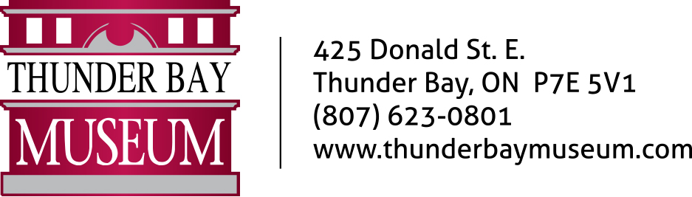

Dear Parent/Guardian of March Break Camp participant,

Thank you for registering for a March Break Camp program at the Thunder Bay Museum.

Enclosed you will find your receipt (if you paid for registration over the phone), a FAQ sheet (on reverse), a photo release form, and an emergency contact form. These forms must be completed and returned prior to the program start date. Your child will not be permitted to stay for the camp unless these forms are fully completed and no refund for the day will be provided.

Please note that drop off is between 9:00-9:30 a.m. and pick up is between 4:00-4:30 p.m. You must wait outside the building to drop off or pick up your child, please see FAQs for more information.

Please send your child with clean, non-skid indoor shoes, an old shirt or paint smock for messy crafts and an extra bag to bring crafts home in. Ensure that the participant has a nut-free lunch (pack an extra drink or water bottle and 2 snacks in addition to lunch), and the following materials for the day registered:

Monday, March 14 | Game Show Day | N/A
Tuesday, March 15 | Around the World in 7 Hours | Recycled pop bottle or water bottle
Wednesday, March 16 | Inventor’s Day | Cardboard (I.e. Shoe box, cereal box, etc.)
Thursday, March 17 | Under the Big Blue Sea | N/A
Friday, March 18 | Top Chef Day | Pizza will be provided for lunch and cupcakes will be made for an afternoon snack

Please do not hesitate to contact me if you have any further questions about March Break or Summer Camps at the Thunder Bay Museum.

Sincerely,

Marissa Nieminen

Education Coordinator
Thunder Bay Museum
425 Donald St. E.
Thunder Bay, ON P7E 5V1
Phone: 623-0801
Email: education@thunderbaymuseum.com

Am I to send a lunch with my child?
Yes, please send a nut-free lunch and two snacks/drinks with your child. There will be no access to a refrigerator, microwave, or water fountain, so please pack accordingly.

Is there an outdoor component to the program?
No.

Am I required to send my child with any materials from home?
Sometimes. Please refer to the chart on the front page of this paper for the entire list. Most times, these materials are simple recyclable items or things you would have around the house.

Can my child wear a costume?
Absolutely! We love to see our campers embracing the theme of the day.

How many children are in each program?
Programs are limited to 8 children. The Museum reserves the right to cancel programs due to under-registration.

What if I have to cancel my registration? What if the Museum has to cancel a program due to under-registration?
The Museum’s cancellation policy is as follows:
- No refunds will be given for cancellations made less than two weeks in advance of the day(s) for which you are registered.
- The museum reserves the right to cancel any under-registered camp days (e.g. less than 50% attendance). In this case, all existing registrants will be notified, and a full refund will be issued.
- A credit for a future program will be given to participants who cancel three days (full 72 hours) before the program start time.
- No credit will be given to “no shows” or to cancellations with less than 72 hours’ notice
- PLEASE NOTE March Break will be cancelled with full refunds and up to 2 weeks’ notice, if there: provincial restrictions put in place, concerns in rising COVID-19 cases, and staff availability
What if my child has special needs?
If your child has any special needs, details must be included with your registration form. Please note that we cannot provide one-on-one supervision or specific medical support. However, if your child requires an adult assistant, they are welcome to accompany the child to camp free of charge.

Who will be supervising my child?
The Education Department’s great staff and volunteers are trained, experienced individuals who have submitted current Criminal Background Checks and are certified in Standard First Aid and CPR. The minimum ratio of supervisors to participants is 1:7.

What are the rules of the Museum?
We ask that your child use the following Museum Manners:
- We walk slowly in the galleries.
- We use indoor voices.
- We stay in a group with our supervisor.
- We touch Museum objects when our supervisor invites us, and we are careful with the things we touch.
Please note: Parents may be called to pick up a child who is causing difficulties, without being issued a refund for the day.

What are the drop-off and pick-up times?
Unless otherwise stated, full-day programs are from 9:30 a.m. to 4:00 p.m. Please drop off your child between 9:00 and 9:30 a.m. and pick them up between 4:00 and 4:30 p.m. Except for in emergency situations, there will be no staff available to supervise before 9:00 a.m. or after 4:30 p.m. so please use the above mentioned times as a strict guideline.

Where do I pick up child(ren)?
Pick up will take place between 4:00 and 4:30 and will look a little different this year. To minimize contact with visitors, we are asking parents and/or guardians must use our delivery door, hit the buzzer, and indicate who they are picking up. A camp leader will then bring down your child(ren) and sign them out.

Where can I find a screening questionnaire?
A screening questionnaire can be found at: https://covid-19.ontario.ca/school-screening/ or completed at the Museum’s front door. If using the online questionnaire, please show us your result for a camp leader to document it. This MUST be done daily.

What are the Museum’s COVID-19 Guidelines?
Upon registration, the Museum’s new Summer Camp policies and procedures will be shared with all families. This document includes:
- Face mask/covering policy
- The sign in/sign out procedure
- Physical distancing measures
- Cleaning and disinfecting
- Screening measures
- Management of suspected cases

.

